**Android Formula Calculator App**

**Project Summary**

I plan to make a fully functioning app for the android using android studios. I will be writing in Kotlin, which I am currently learning. This app will be centered on a quick and easy method to solving an equation that the user inputs without them having to actual type the equation. Essentially they’ll be given a large list of types of equations or measurements they’re trying to solve for. The app will then ask what information they have in which to solve the equation. Since there are multiple different equations that can solve for the same type of measurement, the app will have to determine which one to use based off of this input. If there isn’t enough information they will be informed. If there is they will be issued an answer as well as the correct SI units.

**Personal Goals**

I just want to make an app that isn’t basic or easy. I want to challenge myself to make an app that is the best I can make it within the time that I have. However, I like the idea of my app being useful and this would be highly relevant if I had made it last year to help me with my physics class this year. This is like a test to me. I figure if something as small as this is too difficult or rigorous, then it’s probably not the thing I want to do for the rest of my life.

**Audience**

This project will be geared toward students in general taking any kind of math class (specifically physics). Some students in my physics class complain about how hard it is to set up the equations and so this app will completely fix that. Others complain that it’s too difficult and while this may not teach them much, they’ll be able to get answer without too much thought. There are even a few who say that it’s so easy and it’s tedious to have to set up all the equations and then to solve them. They already know how to do it, why should they have to waste so much time practicing something they know like the back of their hand. This app would save them loads of time and effort they could be putting towards something else. This app will include some physics, algebra, geometry and even some lower level math type equations. This would mean that it would be most useful to 5th through 11th graders.

**Design Vision**

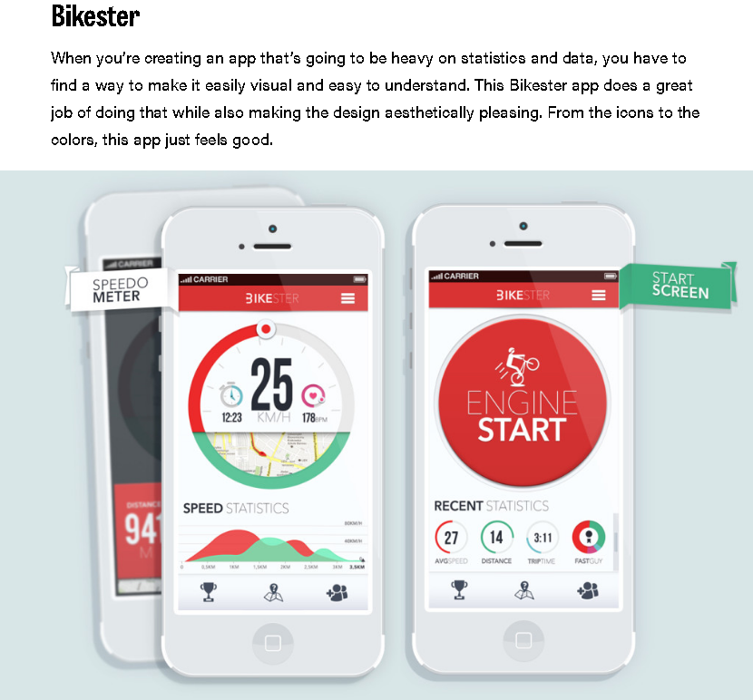

The Bikester app is a perfect example of how I’d like my app to look. I want it to look smooth, appealing and simple so that it’s easy for the user to use. I don’t want them to get confused with how to get it to work or get bored of the layout so much that they decide to just write it themselves because it’s something easier to look at. I want it to draw them in and make it feel as easy to use as possible. I like the idea of the big button in the middle. Maybe I could use it as a “Calculate” button at the end.

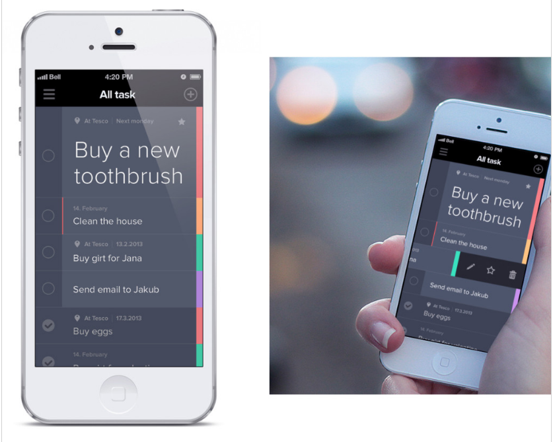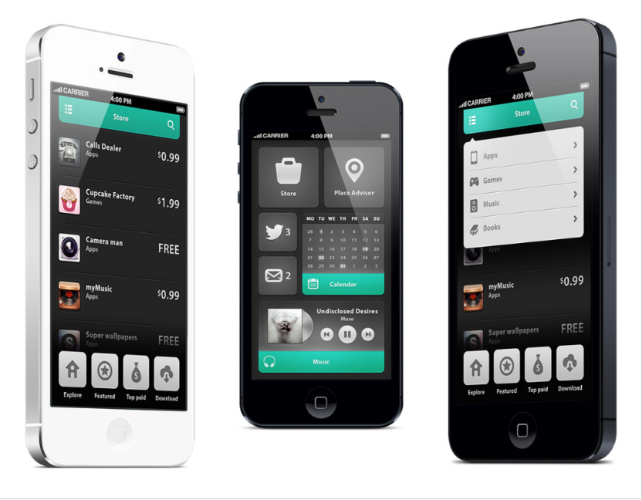

**Functional Requirements**

This app will need to be able to come up with a list of equations based on the key word given by the user. It must also be able to determine the correct one to use in the case of the data that the user gives you. This all would include taking input, sorting it, putting it into the correct function in the correct locations and coming out with the correct answer with the correct SI unit. It should be given an option to restart at any time, including an option change some input at any stage of the process through the use of a confirmation. It also will be able to do unit conversions, such as, miles to kilometers or seconds to hours and so on.